**PSY 653 Module 3: Nested and Incomplete Designs**

**Feb 12, 2020**

*Part 1: In-Class Demo*

Follow along as we talk through the steps of conducting a nested ANOVA. We will use the datafile “Nested_demo.csv” for this exercise, which includes simulated data.

1. Create a new R notebook and load the following libraries: psych and tidyverse
2. Read in the datafile “Nested_demo.csv” and get variable descriptives

This data includes data from 114 patients who participated in study to evaluate the effects of different drugs and treatment conditions on their health. This demo dataset has four variables: Y = the outcome variable for health, H = hospital (i.e., there were two hospitals), D = drug (i.e., four different drugs were tested), C = condition (i.e., six different treatment conditions were tested). This is the underlying structure of the data:

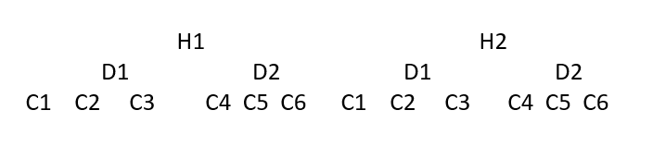

1. How are the variables nested? How does this nesting impact your analysis plan?
2. What are the degrees of freedom for each variable?
3. Use the aggregate function to calculate the mean values of Y by hospital, drug, and condition.
   1. How much do the means of Y vary across the levels of each variable?
4. Run an ANOVA in which Y is regressed on Hospital, Drug, Condition, and the interaction between hospital and condition (i.e., does Y vary across the two hospitals, the two drugs, and the six conditions?).
   1. Interpret this model output.

*Part 2: Try It Yourself*

Use the “Nested_practice.csv” datafile to practice conducting a nested ANOVA on your own.

1. Read in the datafile “Nested_practice.csv” and get variable descriptives

This data includes data from 114 patients who participated in study to evaluate the effects of different drugs and treatment conditions on their health. This demo dataset has four variables: Y = the outcome variable for health, H = hospital (i.e., there were two hospitals), D = drug (i.e., four different drugs were tested), C = condition (i.e., six different treatment conditions were tested). This is the underlying structure of the data:

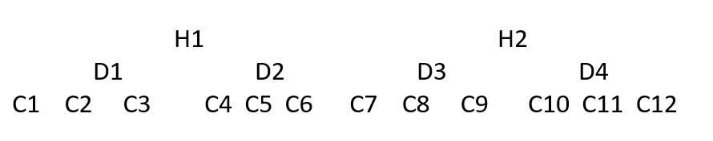

* 1. How are the variables nested? How does this nesting impact your analysis plan?
  2. What are the degrees of freedom for each variable?

1. Use the aggregate function to calculate the mean values of Y by hospital, drug, and condition.
   1. How much do the means of Y vary across the levels of each variable?
2. Run an ANOVA in which Y is regressed on Hospital and Condition nested in Drug nested in Hospital.
   1. Interpret this model output.